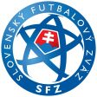
Cordial Cup Slovakia (April 15 - 17, 2016)

Qualification Tournament for Cordial CUP 2016
under the auspices of Slovak Football Association

Patron of the event: Slovak National Team coaches - Mr. Ján Kozák and Mr. Štefan Tarkovič
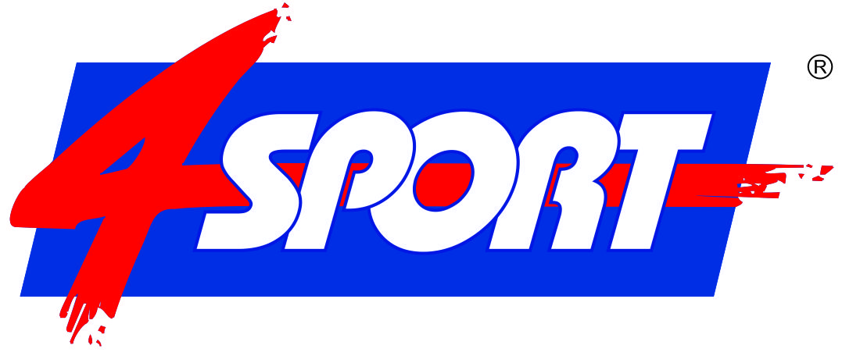
Organizers: 4 SPORT
www.4sport.sk
HG Sportpromotion
www.cordialcup.com

Tournament 4 SPORT Areal
locations: Jazdecká 1/A, 080 01 Prešov, Slovakia

Date: 15th - 17th of April 2016

Age group: U 11 / E-Juniors (born: 2005 and younger)
Small field (6 + 1)

Participants: 32 - 40 teams
Each particpating team has got at least 6 - 7 games.

Playing ground: natural grass pitches; artificial pitch

Prizes: The 1st place - winner obtains the right to play at the final tournament of 19th Cordial Cup 2016 in term 13th - 16th of May 2016 and get a hotel voucher of 300.00 € from HG Sportpromotion and additional voucher of 300.00 € from 4 SPORT for the accommodation costs in one of the Cordial Cup hotel.

The 2nd place - 100% discount of accommodation and full board (student hostel) on tournament Fragaria Cup 2016 (July 2nd - 6th) for max. 16+2 persons.

The 3rd place - 50% discount of accommodation and full board (student hostel) on tournament Fragaria Cup 2016 (July 2nd - 6th) for max. 16+2 persons

The 1st, 2nd and the 3rd placed will receive winning cup, medals and diploma. In tournament will be awarded the best goal-keeper, player and scorer.

Accommodation and board:
Category A: Hotel 4* accommodation + breakfast: 42,- € / person / day

Category B: Pension 3* accommodation + full-board: 35,- € / person / day

Category C: Hotel 2* accommodation + full-board: 30,- € / person / day

Category D: stud.hostel accommodation + full-board: 20,- € / person / day

Others: Possibility to arrange accommodation and meals at discounted prices for parents
and fans: Ing. Eva Benesová +421-915 873 349, beneg@nextra.sk

Application 15th of March 2016
deadline: The deadline for submitting the application and paying the entry fee 100,- €
or 200,- € / team!

Contacts: Helena Janigová +421 915 873 134 Artúr Benes +421 915 963 035
Mail: cordialcup@4sport.sk Mail: benes@arrpsk.sk

HG Sportpromotion, Hans Grübler
Mail: info@hg-sport.de

